EX.NO:04

DATE:14.10.2020

AIM:

To swap first two character from the given two strings.

**PROGRAM:**

def convert(s):

new=""

for x in s:

new+=x

return new

a=input()

b=input()

s1=a.strip()

s2=b.strip()

if(len(s1)>=2 and len(s2)>=2):

t1=list(s1)

t2=list(s2)

c1=t1[0]

c2=t1[1]

t1[0]=t2[0]

t1[1]=t2[1]

t2[0]=c1

t2[1]=c2

s1=convert(t1)

s2=convert(t2)

print(s1," ",s2)

else:

print("Invalid")

**LINK:**

http://103.53.53.18/mod/vpl/forms/edit.php?id=234&userid#vpl_file0

**OU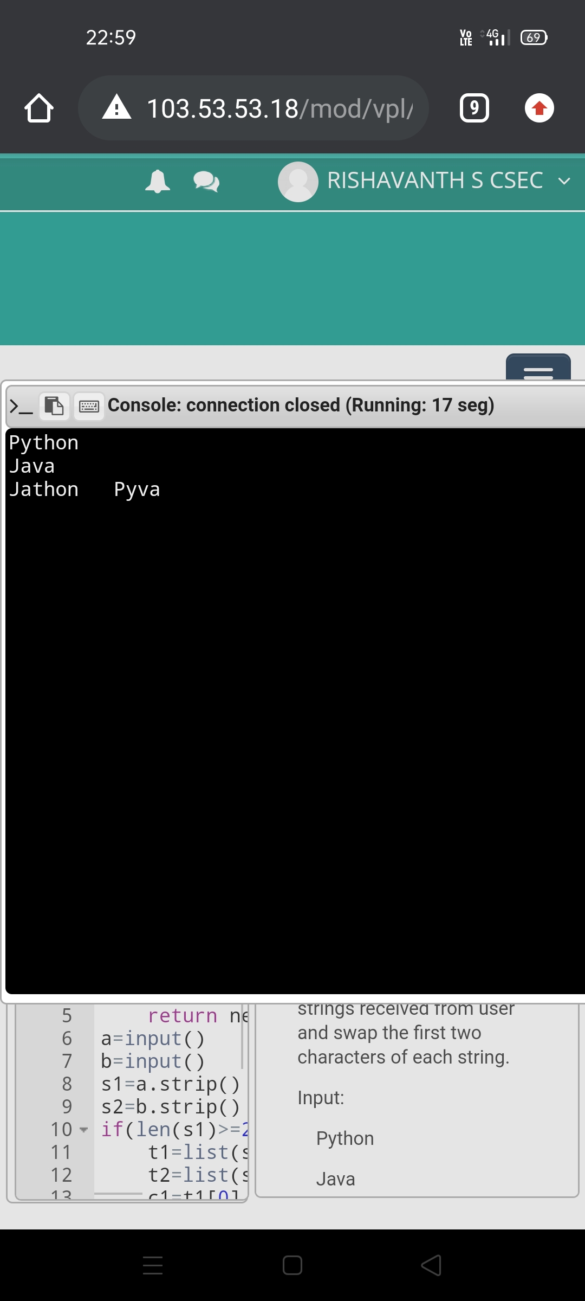TPUT:**

**RESULT:**

The output of the program is successfully obtained.